
Intro to FlowJo 11 Workshop

Please complete these downloads and installs prior to the session. If you encounter any issues, contact me to troubleshoot (veronica.obregon-perko@bd.com)

Device Requirements for FlowJo™ v11 Software
Note: Devices that do not meet minimum recommended requirements may experience slower performance in gate and algorithm calculations in this version.
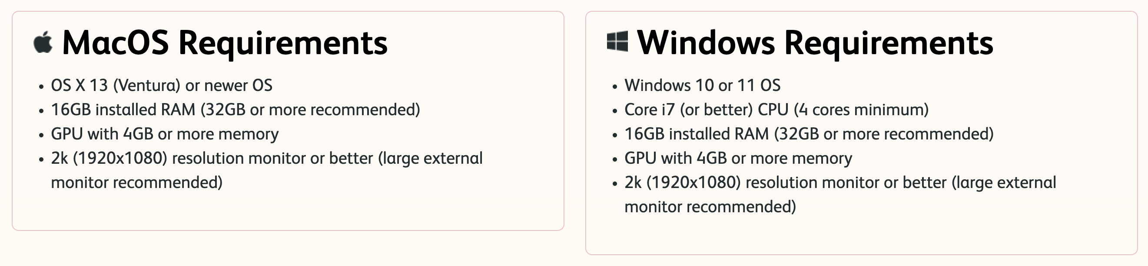
Demo Data Download
- Download the following data: https://drive.google.com/file/d/19M5MlpH9-ewH8qcXzSOydPXTk56VJfXI/view?usp=sharing
- Extract the files from the zipped folder and save them locally to your device (not on cloud or server locations)
FlowJo™ v11 Software Download and Installation (more info on our website: https://www.flowjo.com/docs/flowjo11/license-info)
Note: If you already have an active FlowJo portal account, you do not need to create another account or request a temporary license for BD Access Portal. Serial number and dongle licenses will need a portal license to authenticate FlowJo 11. With portal licenses, FlowJo 11 can be activated with your Portal ID on up to four devices, so just download the most recent version of FlowJo 11 on your device and you will log in as usual.
- Download and install FlowJo 11.0.2 from: https://flowjo.com/flowjo/download. Be sure both FlowJo 11 and BD Access Portal are installed to your Program Files for PC or Applications for Mac.
- If you do not have a FlowJo portal account, contact me to request a temporary license then proceed to following steps. If you have an account, proceed to step 4.
- You will receive an invite to join a temporary site license and asked to create a Portal ID (e-mail login) which will be used to authenticate the software on your device. License activation can take up to 15 minutes.
- While connected to the internet, launch the BD Access Portal and log in with the credentials for your FlowJo Portal account. The globe icon should turn green (yellow indicates failure to reach server, red indicates no internet connection).

